# CS 255 System Design Document

Kiersten Grove | SNHU CS 255 | 9 October, 2023

## UML Diagrams

### UML Use Case Diagram

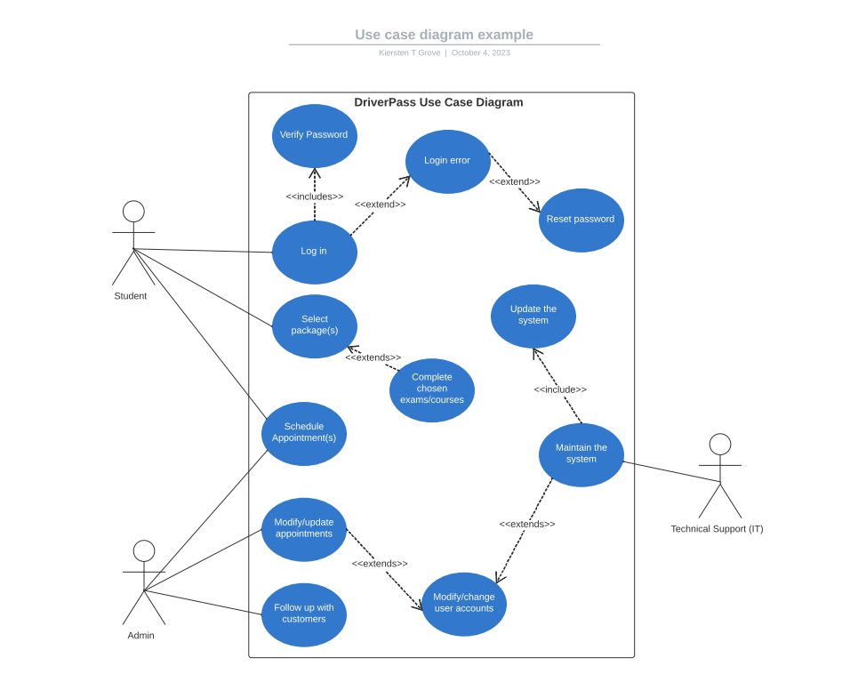

### UML Activity Diagrams

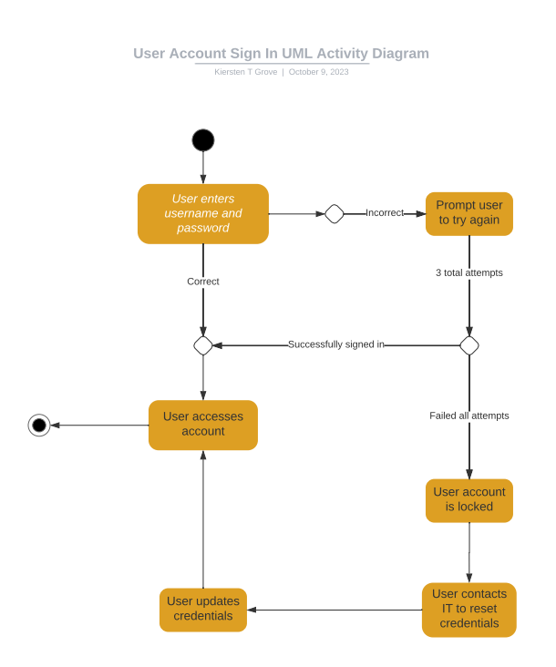

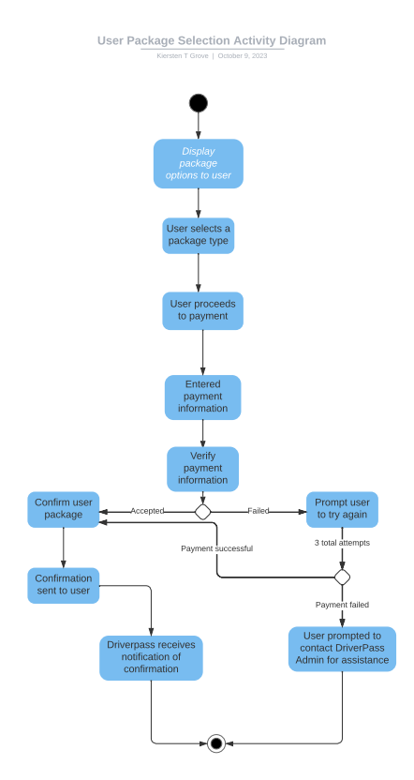

### UML Sequence Diagram

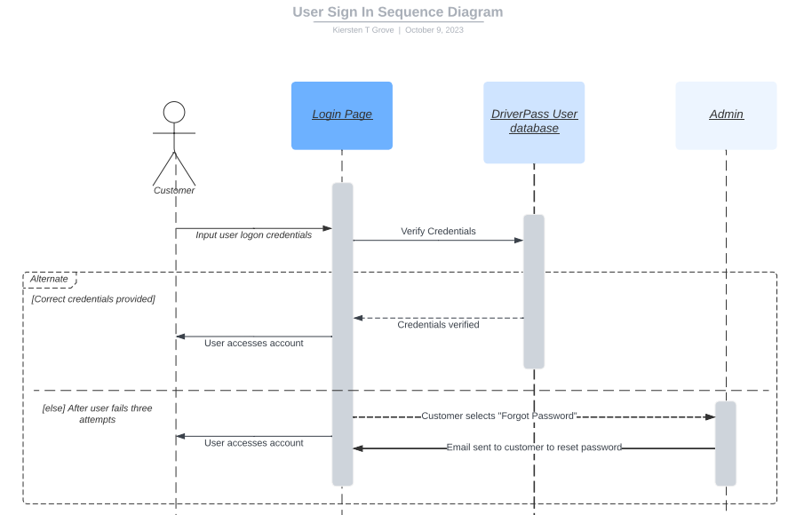

### UML Class Diagram

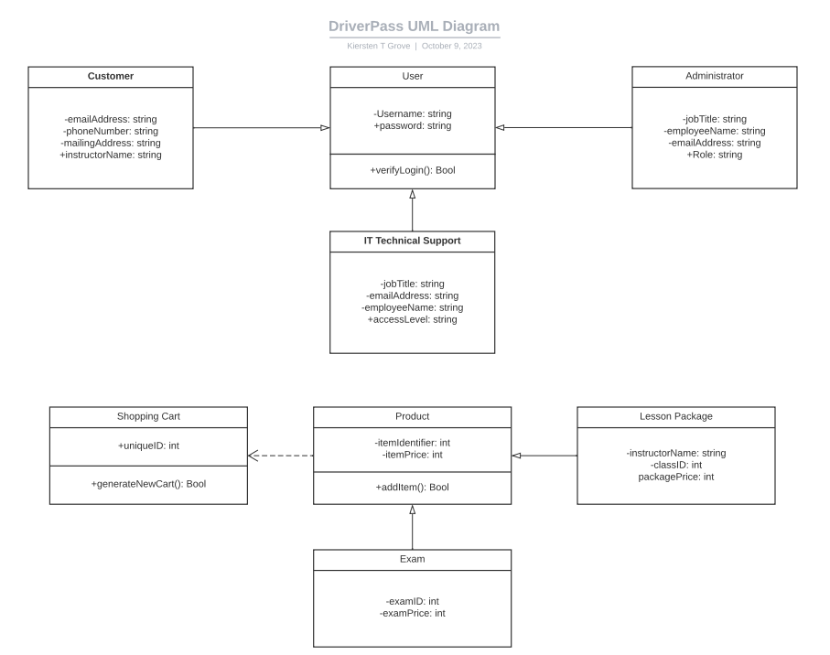

## Technical Requirements

The DriverPass system will require multiple databases to contain both customer and proprietary data. The user will require the proper device and internet access to create and manage an account including selecting and paying for a package(s) provided by DriverPass. DriverPass will be required to host a server that makes all necessary components available to every user based on access level.